**Waste Table 4–Reducing single-use plastics**

In FY23 we decreased single-use plastics to 2.7% across all Microsoft product packaging.

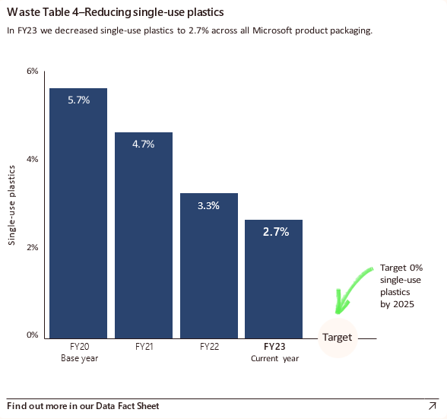

Bar graph showing the percentage of single-use plastics across all Microsoft product packaging from fiscal years FY20 to FY25. The X-axis denotes the fiscal years, while the Y-axis represents the single-use plastics percentage. The data shows a progressive decline in single-use plastics, beginning at 5.7% in FY20, decreasing to 4.7% in FY21, further reducing to 3.3% in FY22, and reaching 2.7% in FY23. The target is to achieve 0% single-use plastics by 2025.